12.Design DFA using simulator to accept the input string “a” ,”ac”,and ”bac”.

OUTPUT:

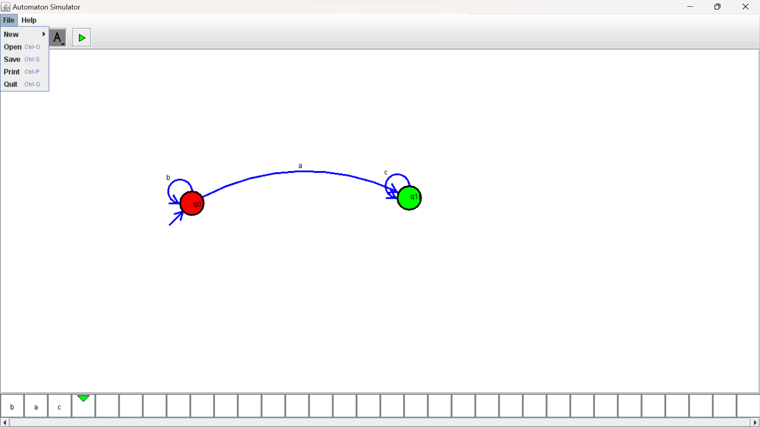

13 Design PDA using simulator to accept the input string aabb

OUTPUT:

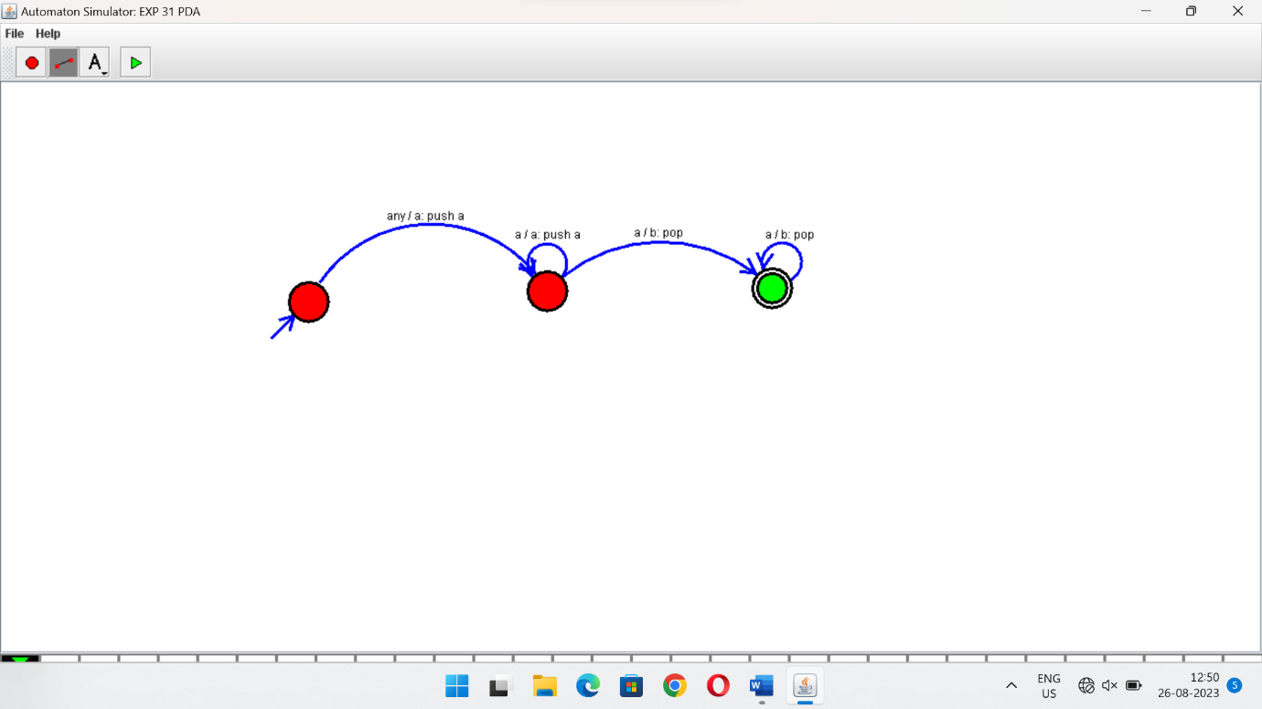

1. Design PDA using simulator to accept the input string anb2n

OUTPUT:

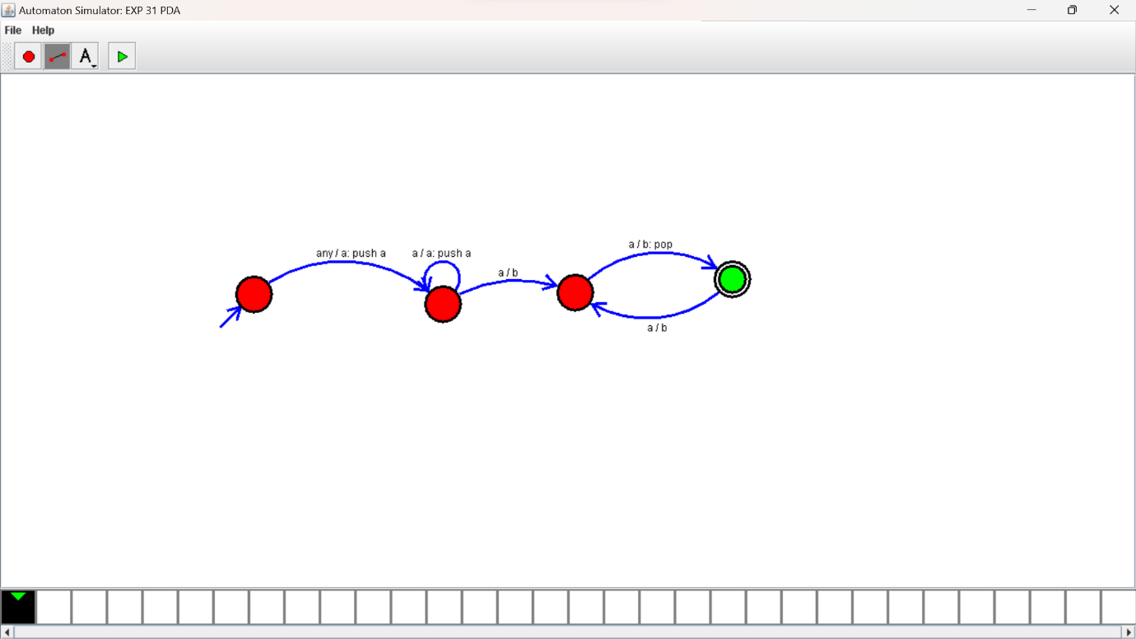

1. Design TM using simulator to accept the input string anbn

OUTPUT:

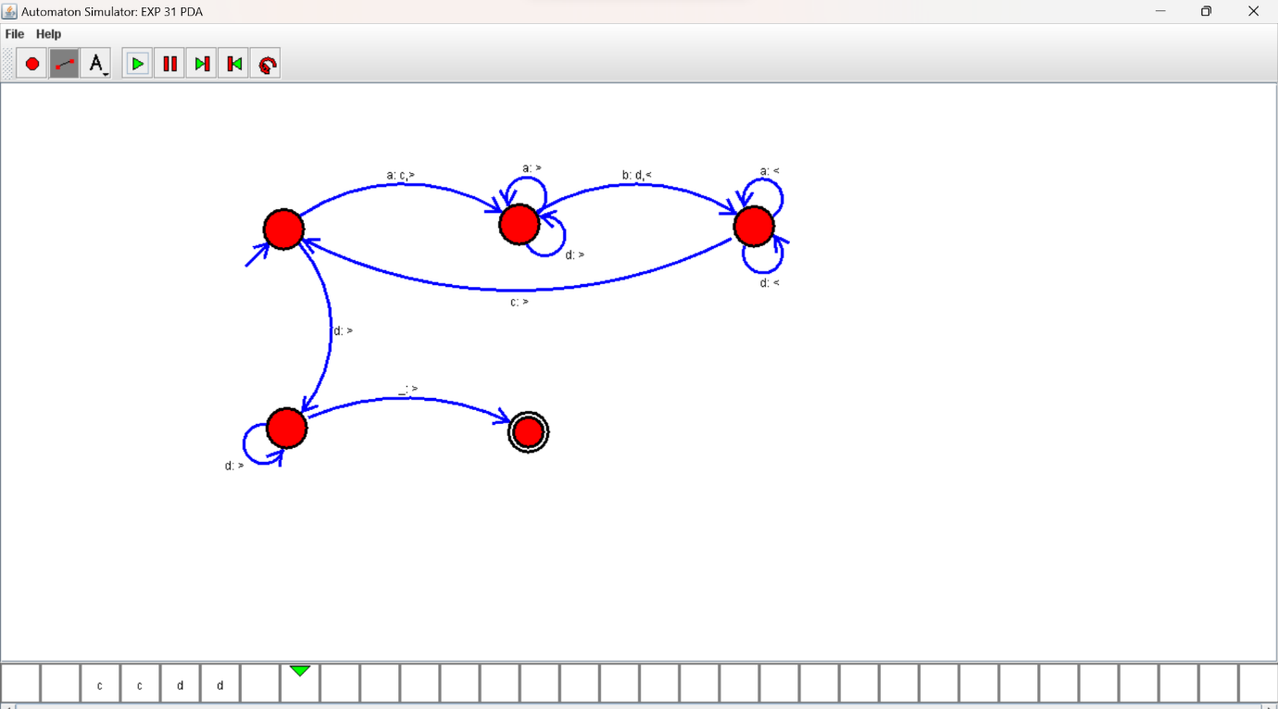

1. Design TM using simulator to accept the input string anb2n

OUTPUT:

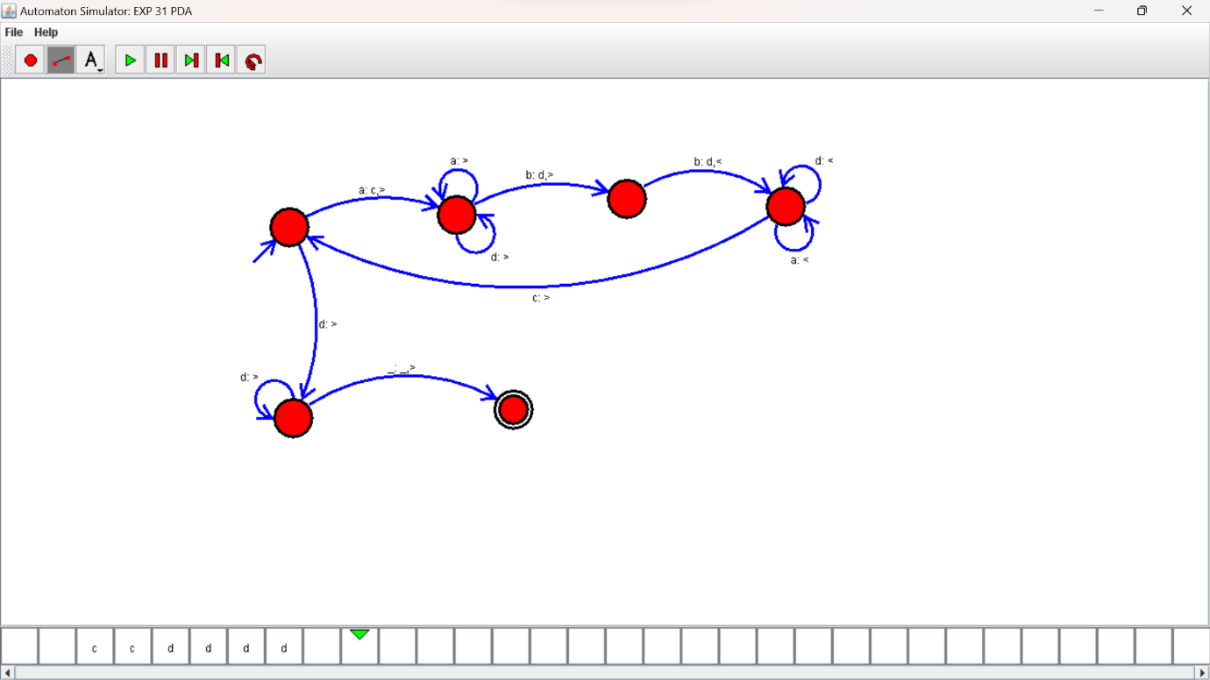

17.Design TM using simulator to accept the input string Palindrome ababa\

OUTPUT:

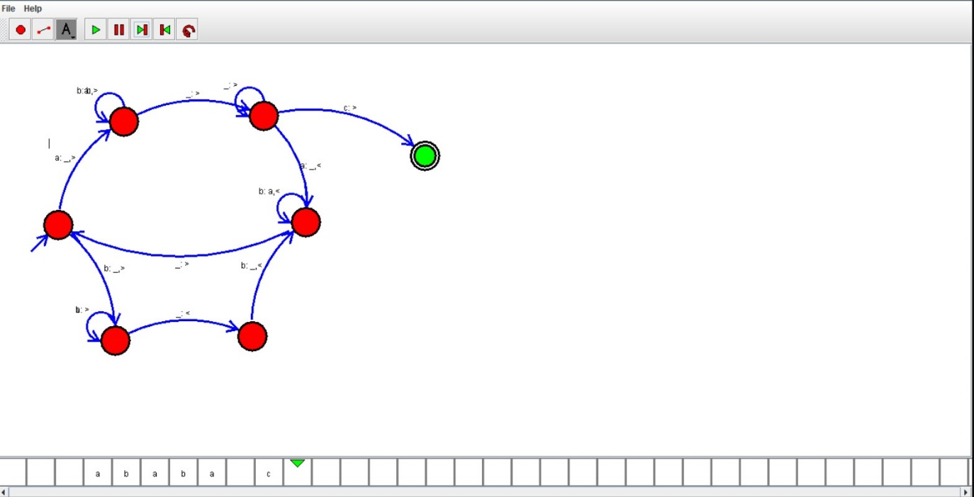

1. Design TM using simulator to accept the input string ww

OUTPUT:

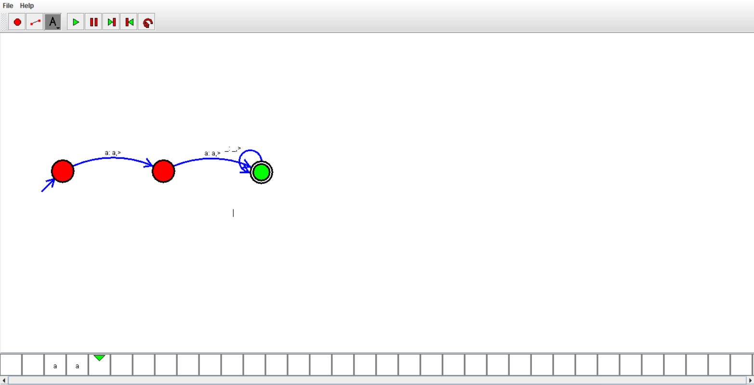

1. Design TM using simulator to perform addition of ‘aa’ and ‘aaa’

OUTPUT:

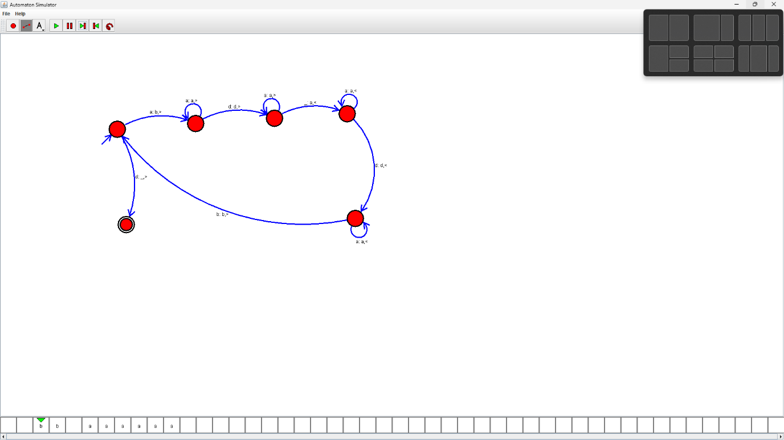

1. Design TM using simulator to perform subtraction of aaa-aa

OUTPUT:

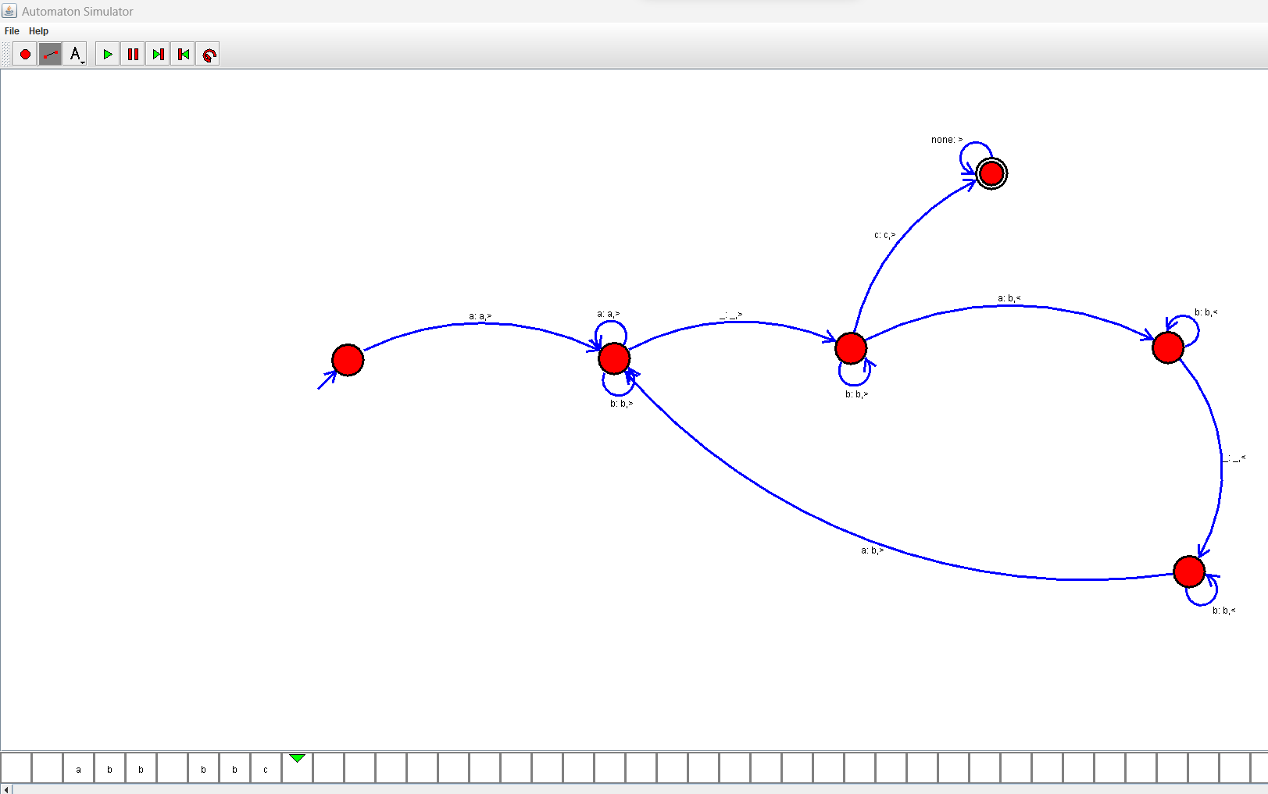

21.Design DFA using simulator to accept even number of a’s

OUTPUT:

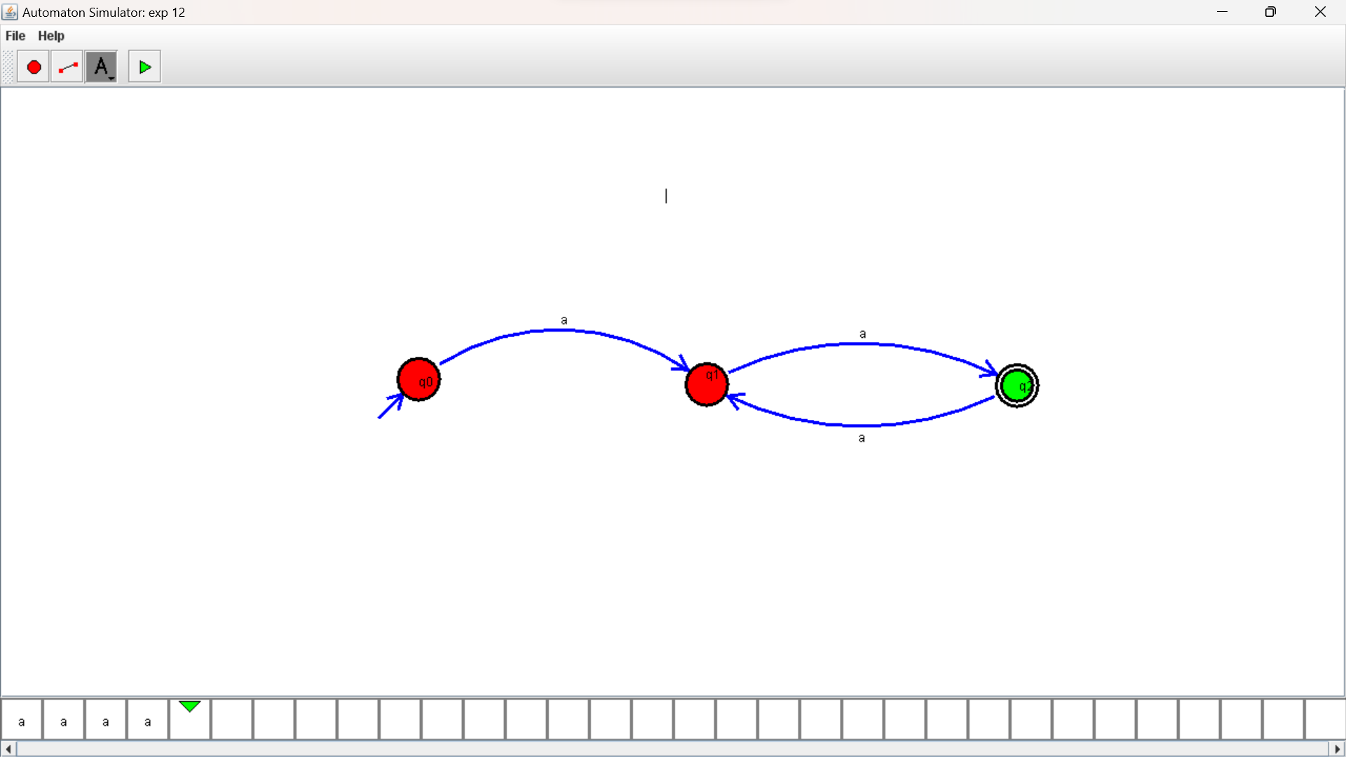

1. Design DFA using simulator to accept odd number of a’s

OUTPUT:

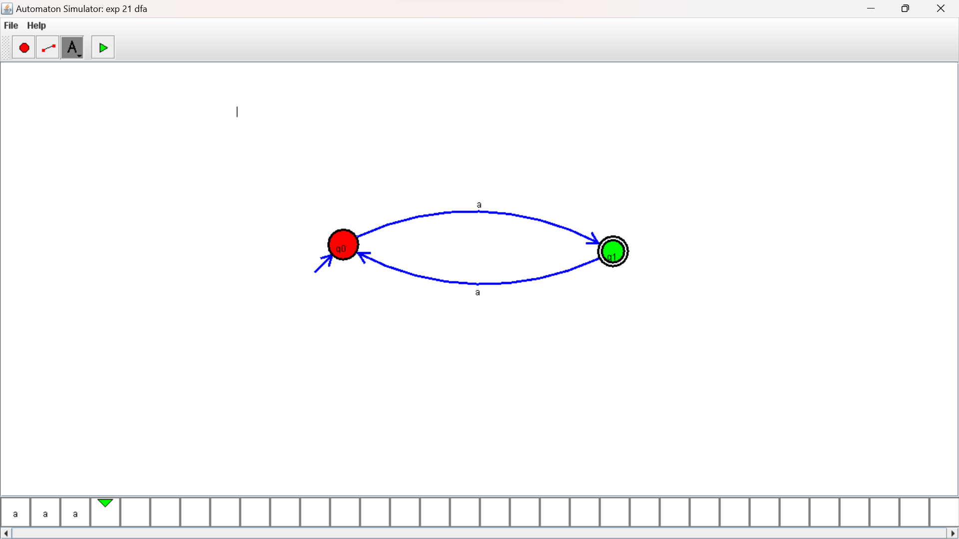

1. . Design DFA using simulator to accept the string the end with ab over set {a,b)

W= aaabab

OUTPUT:

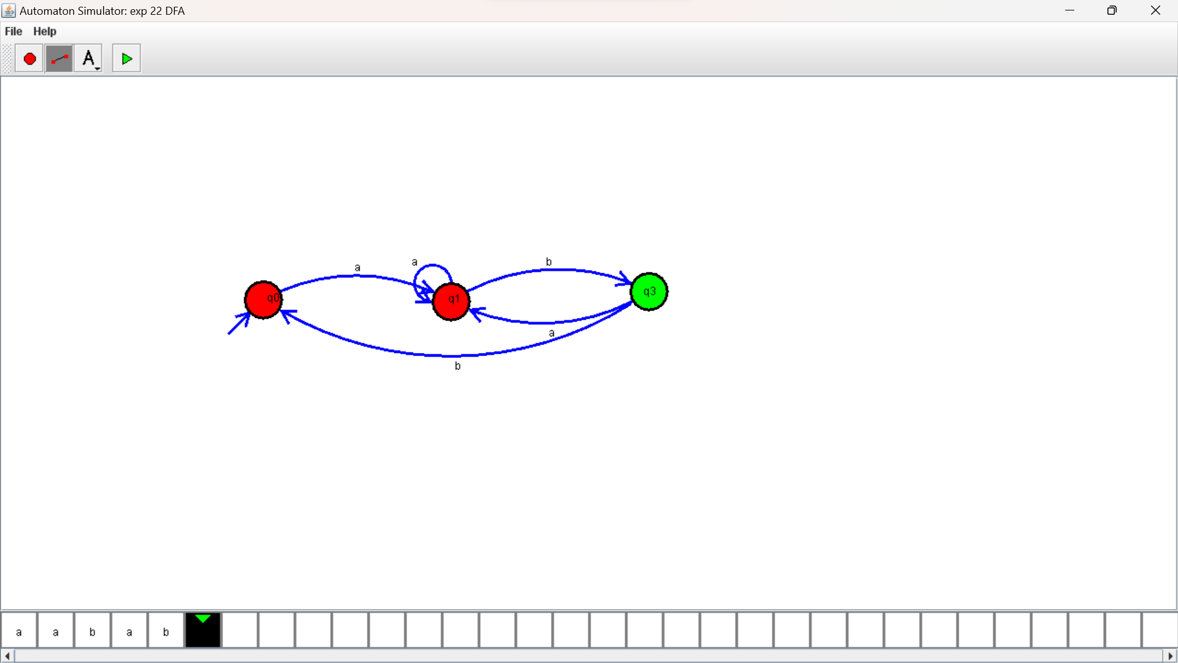

1. Design DFA using simulator to accept the string having ‘ab’ as substring over the set {a,b}

OUTPUT:

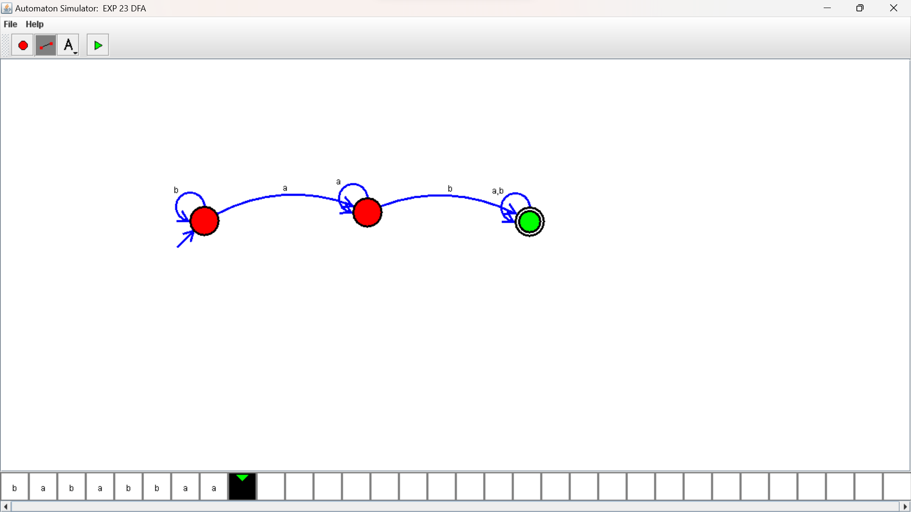

1. Design DFA using simulator to accept the string start with a or b over the set {a,b}

OUTPUT:

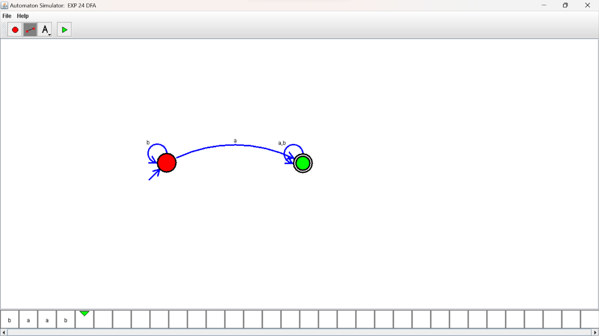

1. Design TM using simulator to accept the input string Palindrome bbabb

OUTPUT:

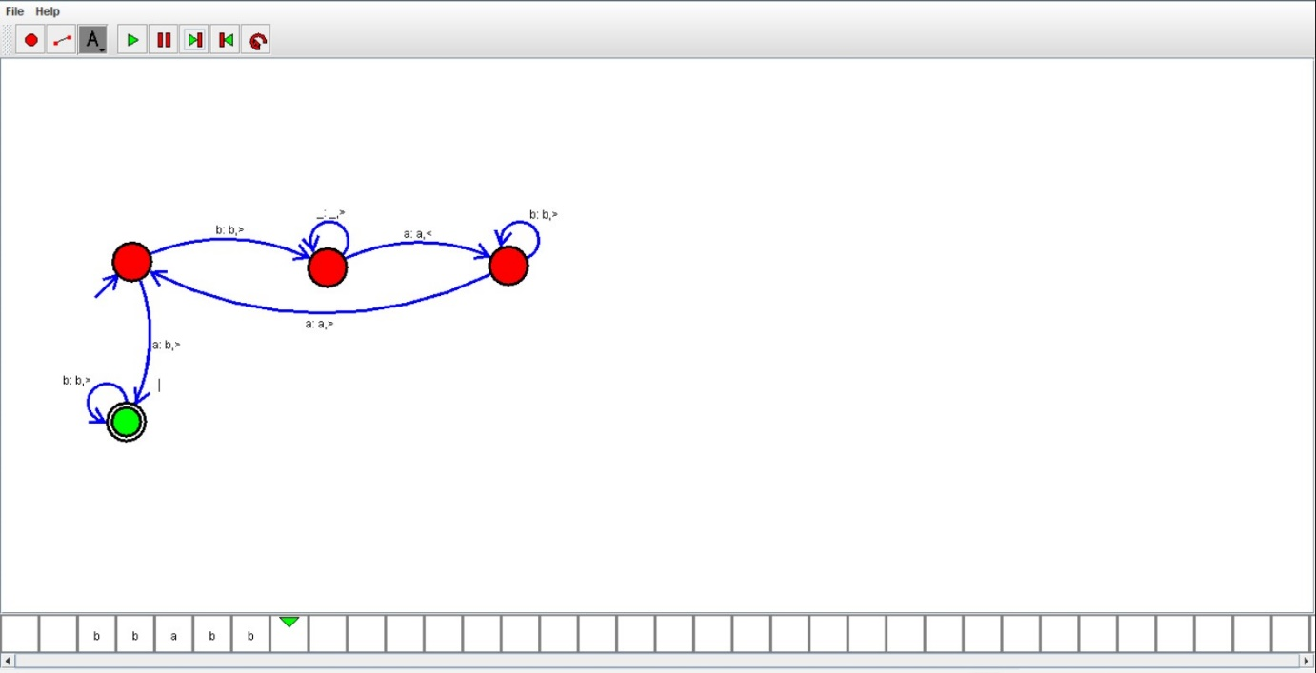

27.Design Tm using simulator to accept the input string wcw

OUTPUT:

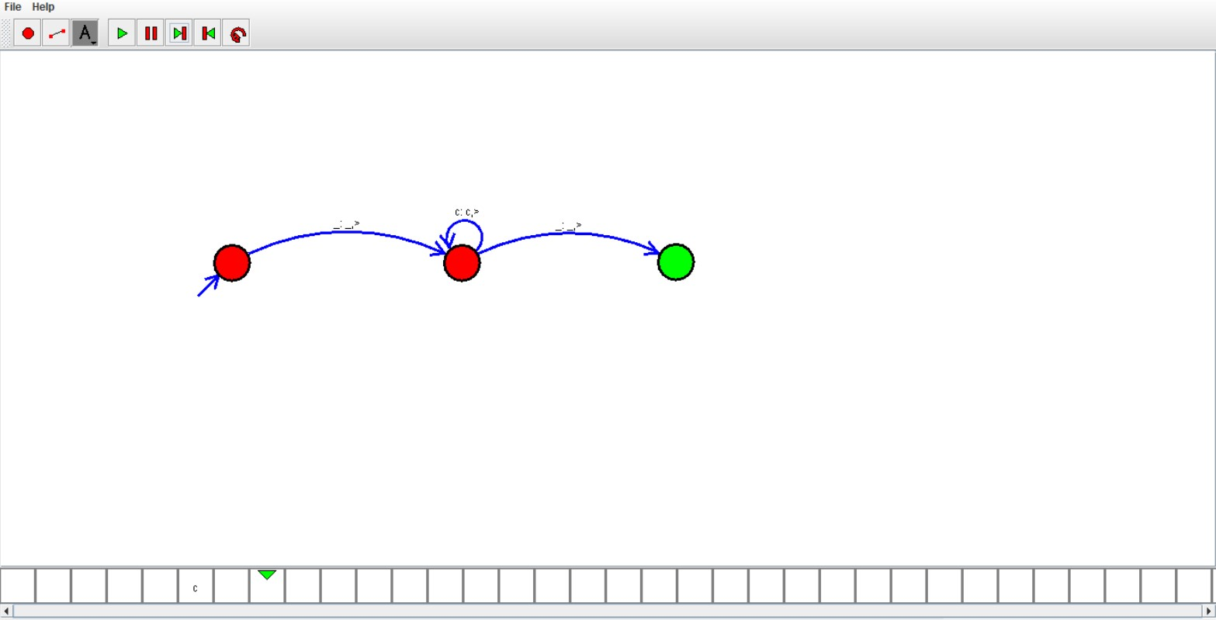

1. Design DFA using simulator to accept the string the end with ab over set {a,b)

W= abbaabab

OUTPUT:

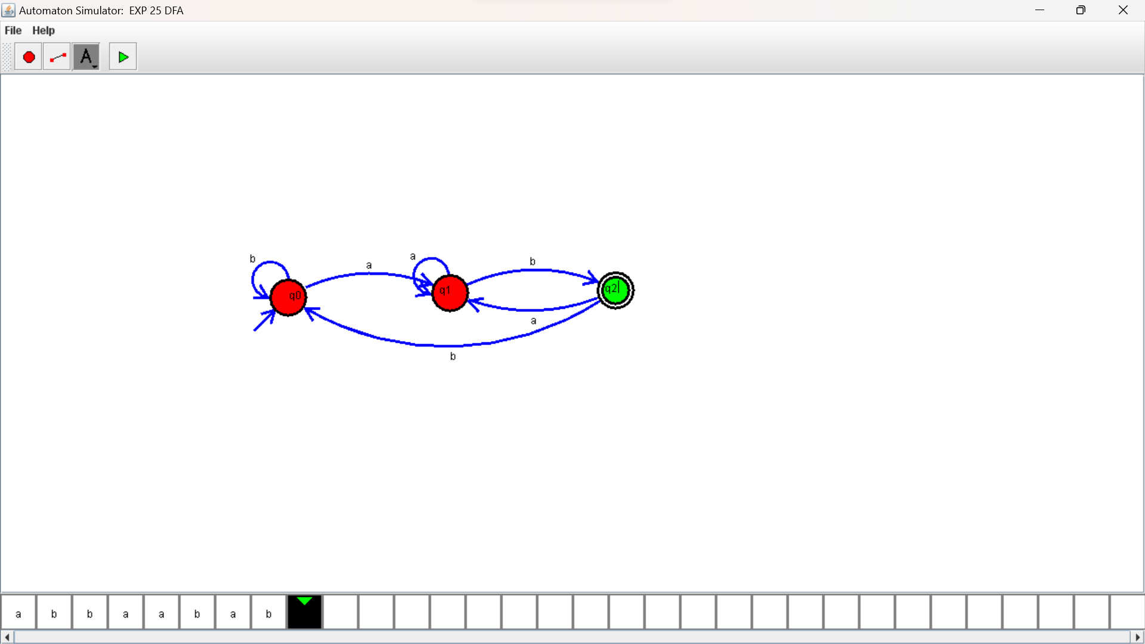

29. Design DFA using simulator to accept the input string “bc” ,”c”,and ”bcaaa

OUTPUT:

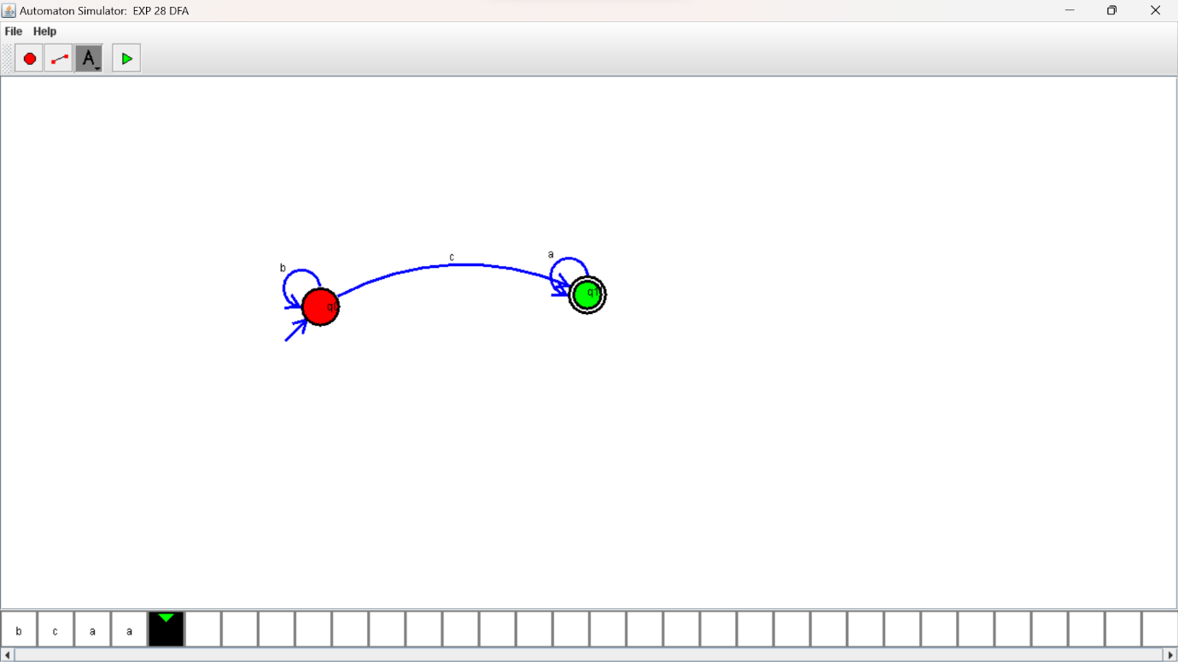

1. Design NFA to accept any number of a’s where input={a,b}.

OUTPUT:

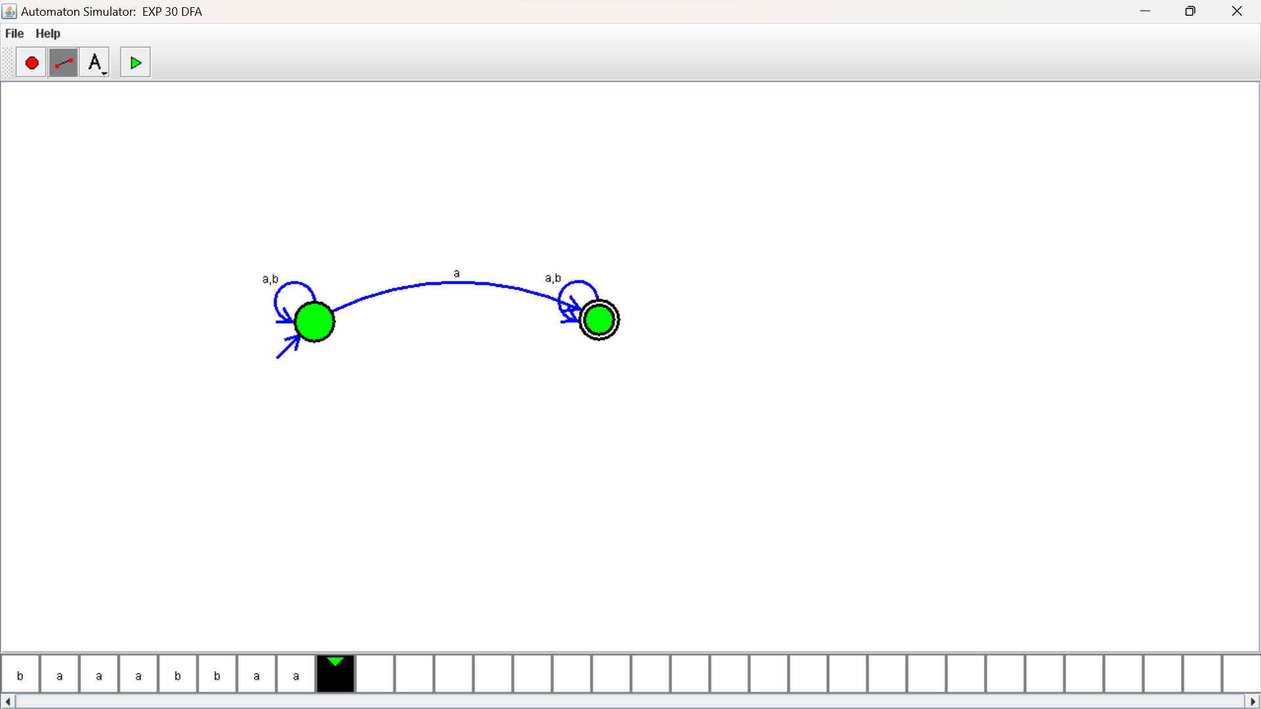

1. Design PDA using simulator to accept the input string anbn

OUTPUT:



1. Design TM using simulator to perform string comparison where w={aba aba}

OUTPUT:

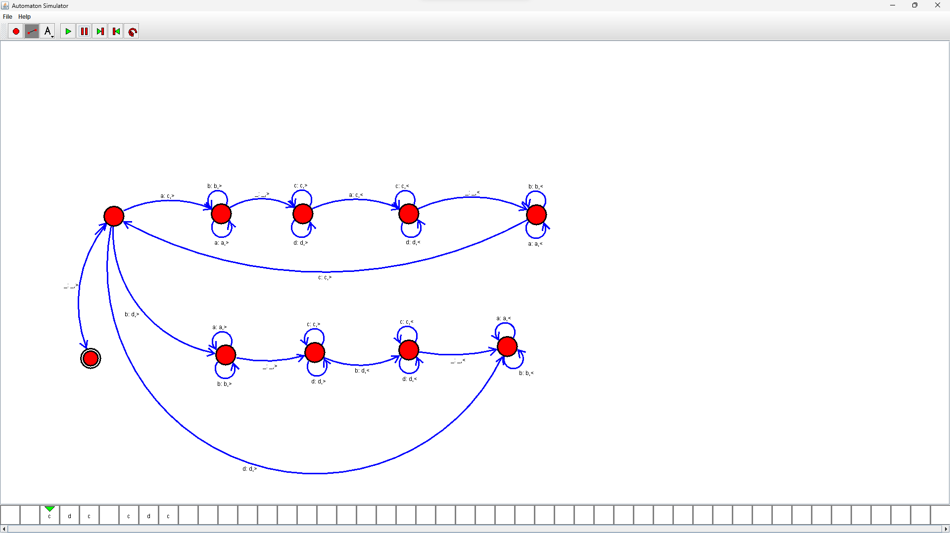

1. Design DFA using simulator to accept the string having ‘abc’ as substring over the set {a,b,c}

OUTPUT:

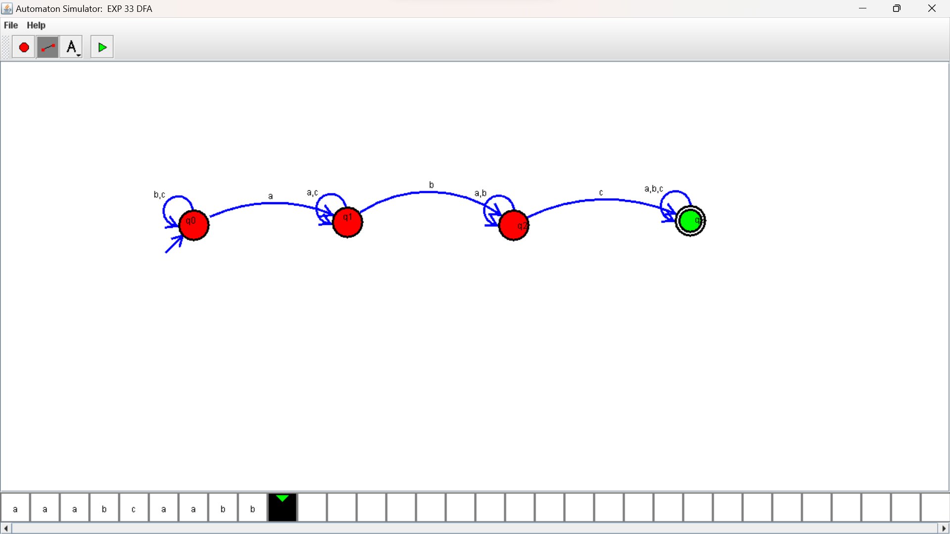

1. Design DFA using simulator to accept even number of c’s over the set {a,b,c}

OUTPUT:

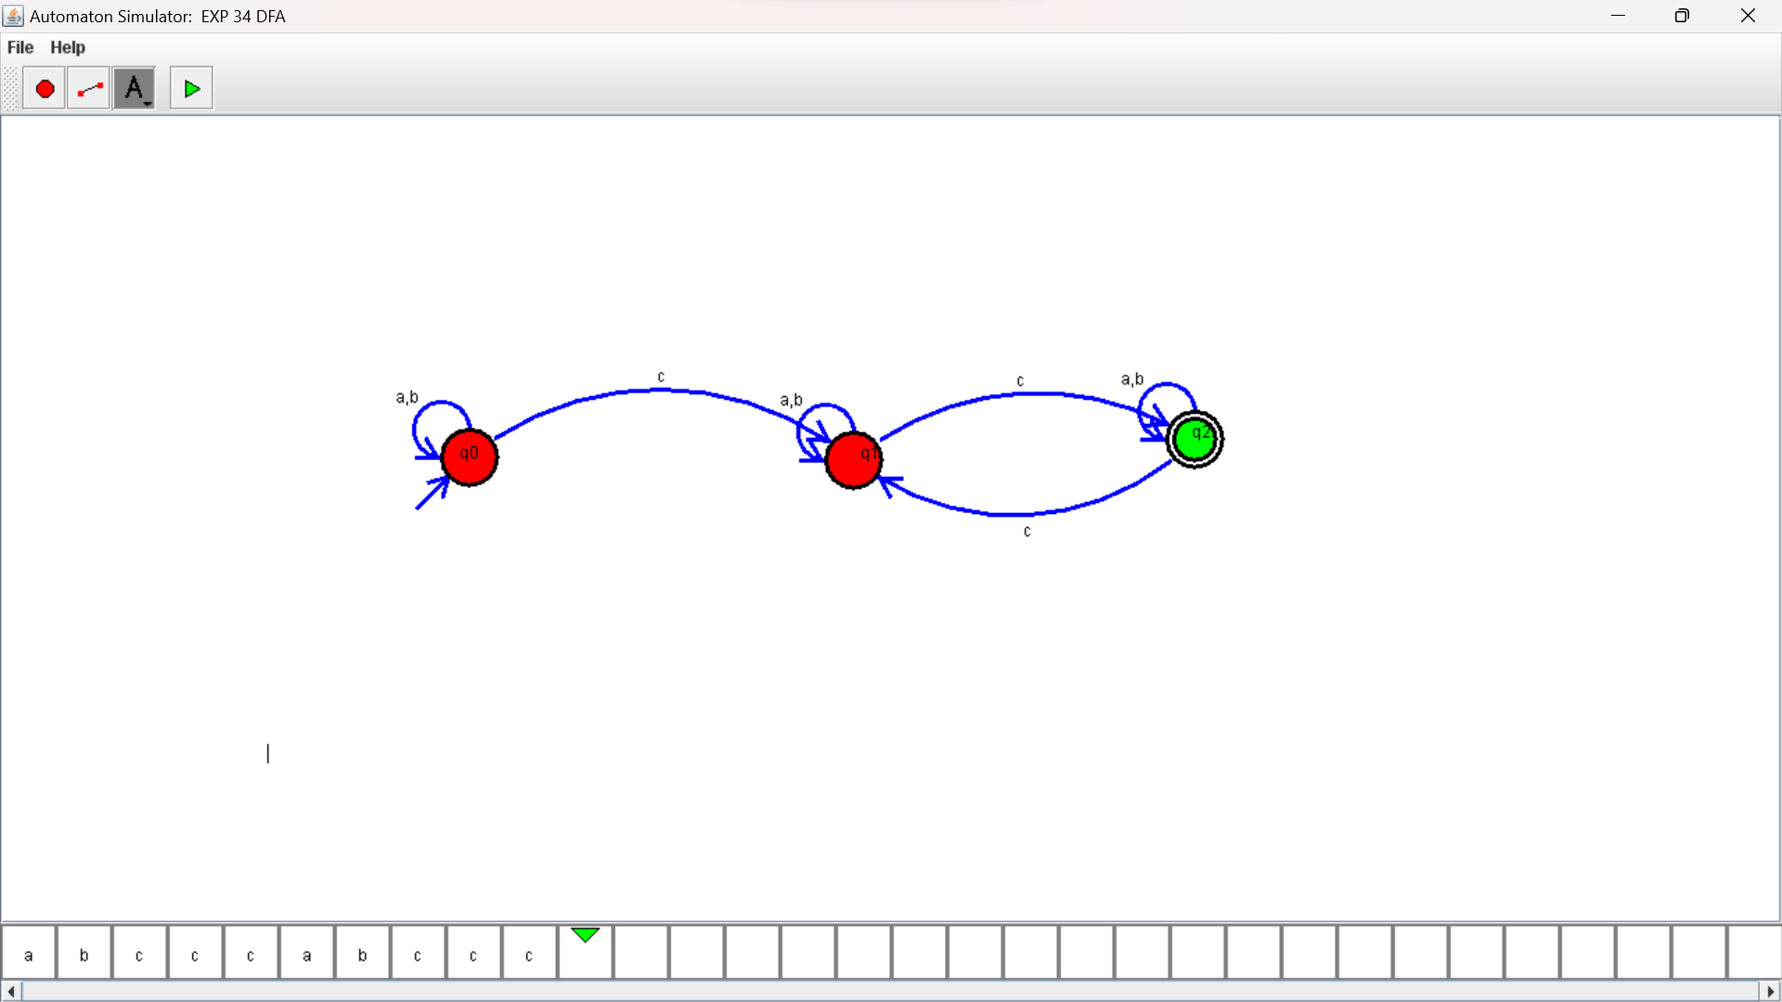

1. Design DFA using simulator to accept strings in which a’s always appear tripled over input {a,b}

OUTPUT:

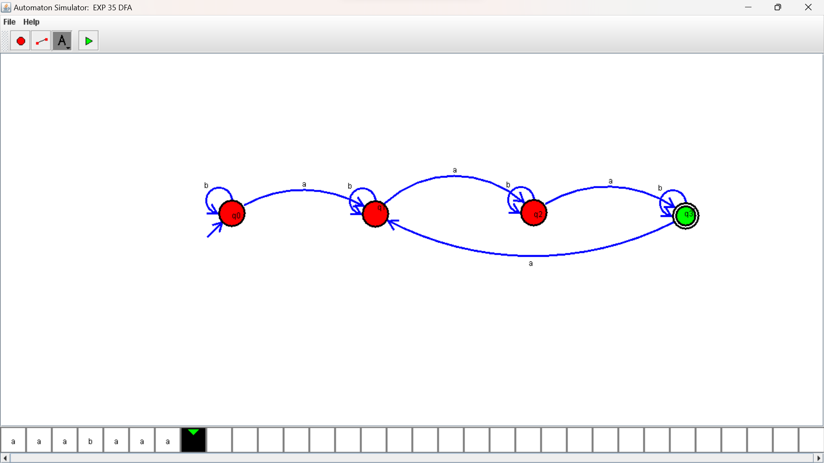

36. Design NFA using simulator to accept the string the start with a and end with b over set {a,b} and check W= abaab is accepted or not

OUTPUT:

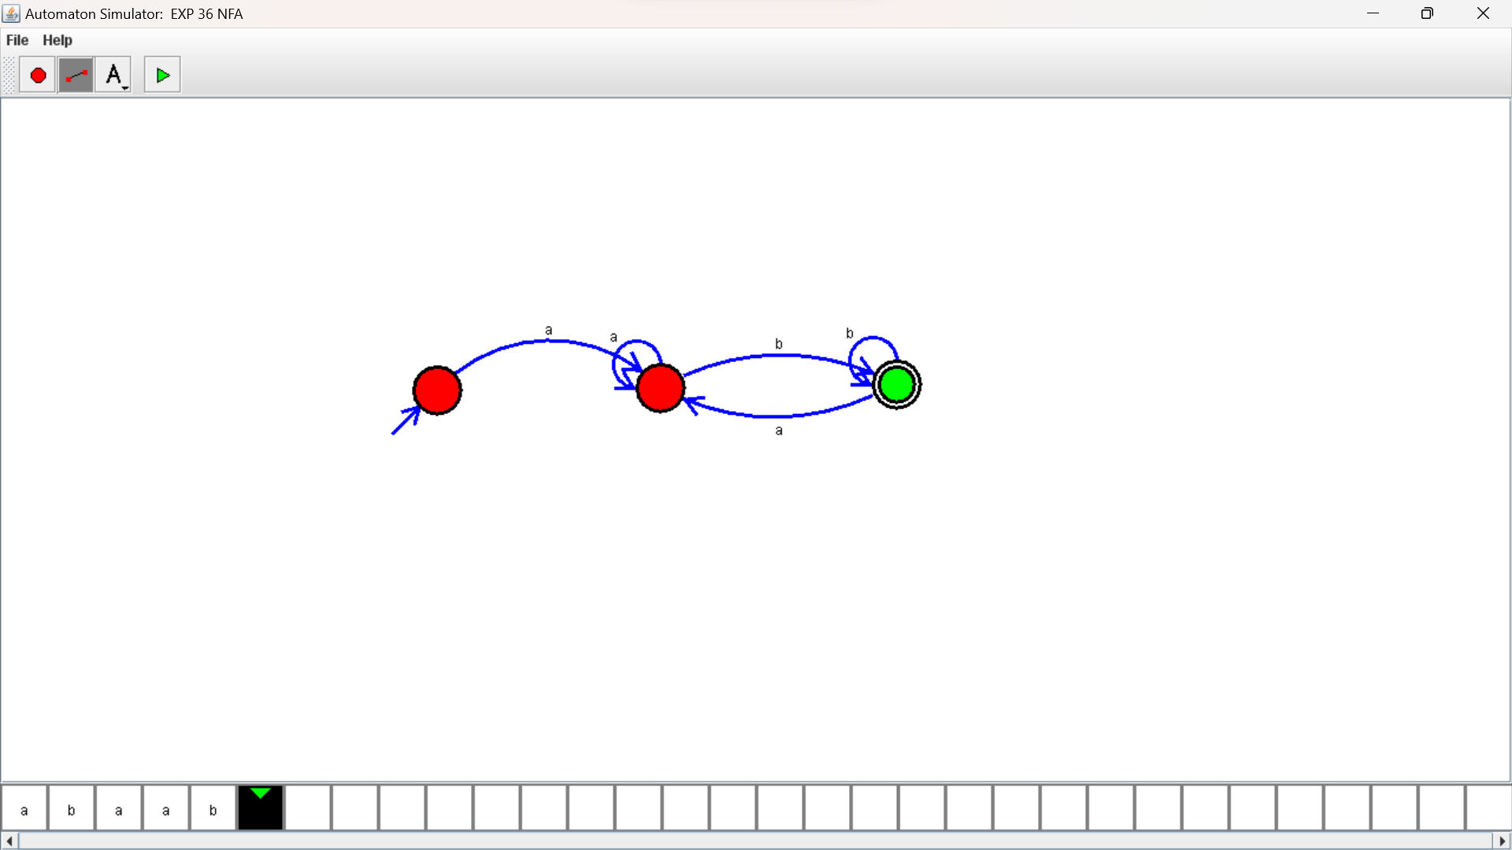

37, Design NFA using simulator to accept the string that start and end with different symbols over the input {a,b}.

OUTPUT:

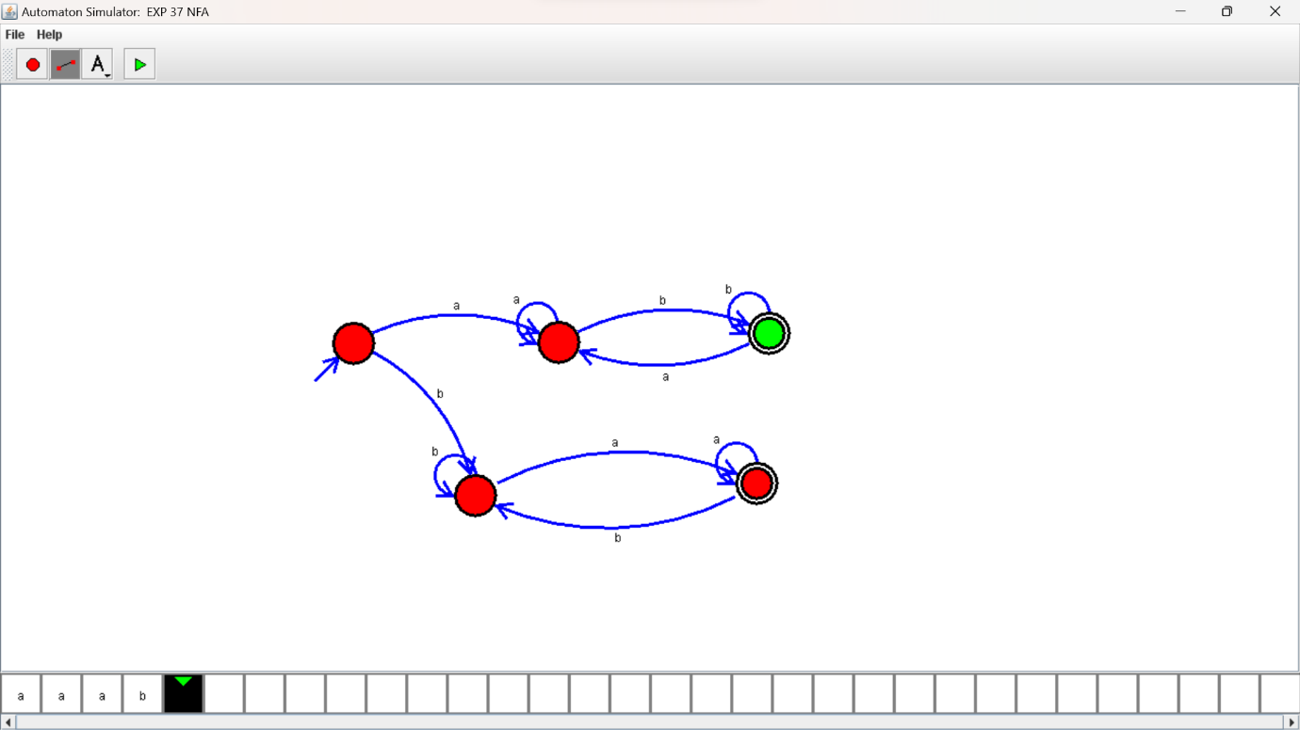

1. Design NFA using simulator to accept the input string “bbc” ,”c”,and ”bcaaa”.

OUTPUT:

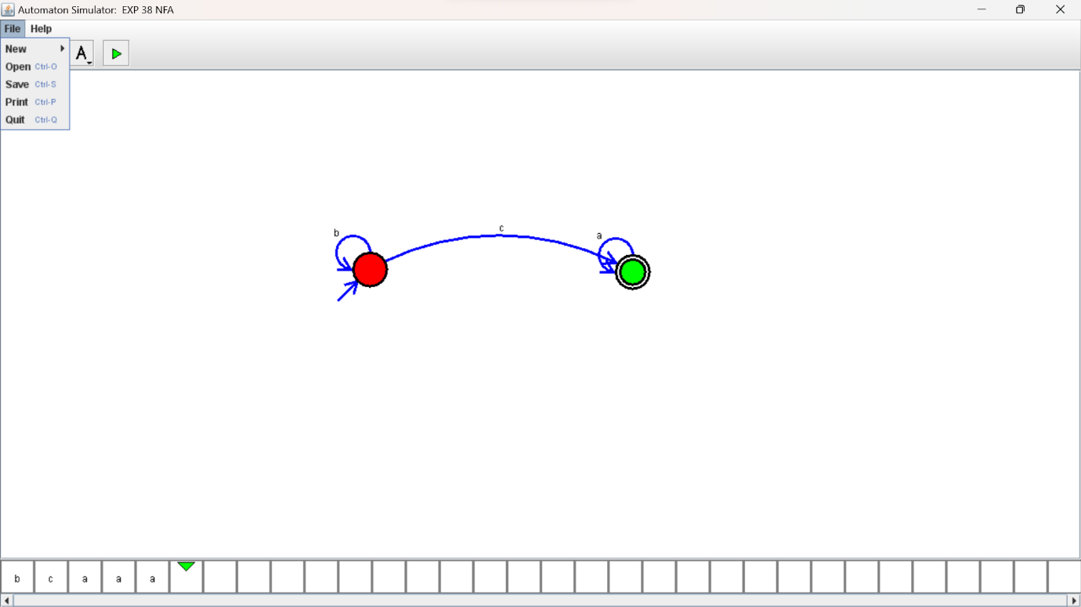

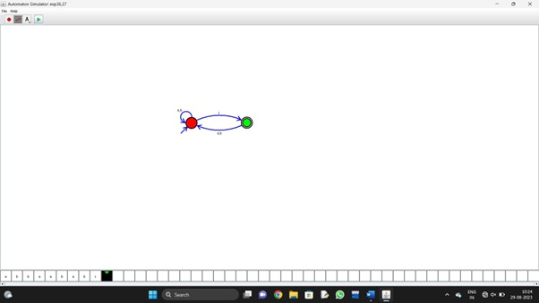

40.Design NFA to accept any number of b’s where input={a,b}.

OUTPUT:

